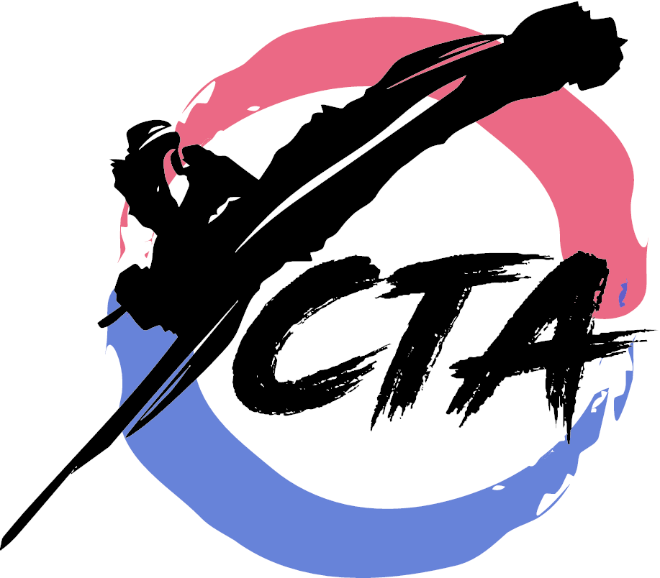Cho’s TaeKwonDo BELT TEST 1. 27326 Robinson Rd, Oak Ridge N,77385 281.367.0101 / 832.212.3339 2. 2733 Rayford Rd, Spring, TX 77386
3. 22632 Kuykendahl Rd, Spring, TX 77389 Grand Master Isaac Cho www.chotkd.com chotkd1@gmail.com
Master Paul Cho, Master Bill Gibbs ………………………………………………………………………………………………………………………………………………………………
Qualifications and Requirements for Belt Testing:
Minimum of 8 weeks or 16 classes. When you receive 3 tips, you can apply without approval.

_______________________ _________________ ________________ Student Full Name Testing Date Applied Belt
(Mark date on your calendar)
Deadline: ___________ (Please bring check, cash with testing sheet before the deadline)
Make Checks Payable to Cho’s TaeKwonDo (TKD)
Note: This form must be filled out completely, and turned in to the school on or before the deadline date indicated above in order for student to be able to test for his or her next belt.
Testing Fee by Belt Levels (Circle):
Beginners (Yellow, Orange): $47 Intermediates (Green, Purple): $52
Advanced (Blue, Brown, Red): $57 Junior Black (Poom): $125
*Off-Campus/Private Test: Additional $10 Date / / Time:_______________
ALL STUDENTS ATTENDING SCHOOL (Kindergarten through High School):
The following factors will be taken into consideration for the promotion to the next belt:
- Completes Homework: (Yes) (No) B. Improved Listening Skills: (Yes) (No)
- Respects Family Members: (Yes) (No) D. Acceptable Grades: (Yes) (No)
*If a student receives all A’s, bring a copy of report card on Dec. or May Test to receive a medal!
Parent’s Comments:_____________________________________________________________
Grades: Manners ( ) Spirit ( ) Blocks ( ) PoomSae ( ) Kicks ( )
Self-Defense ( ) Sparring ( ) Weapons ( )

Fee paid: ______________ Parent (Guardian) Signature: _____________________________

