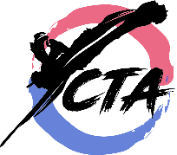
. TaeKwonDo / Ivy Kids 2018 Fall
Offered by Cho’s TaeKwonDo Academy

Grand Master Isaac Cho, 9th Degree Black belt, 30 years teaching experience
Since 1992 in The Woodlands.

- Class Schedule: Oct. 2th – Dec. 18th at Ivy Kids
Every Tuesday 9:30 – 10:05AM
- $59 per Month, No registration fee
- T-shirts FREE ($15 Cost)

All TaeKwonDo Basic Skills, Blocks, Self-Defense and Kicks.
The benefits of TaeKwonDo training:
- Focus, Respect, Self-Esteem, Self-Control
- Endurance, Coordination, Flexibility, Speed
- Learn Self-defense skills with Kicks, Blocks and PoomSae (Forms)
- Fun exercise for all ages
- Great for fitness, diet and daily exercise

Cho’s Taekwondo Academy
27326 Robinson Road, Oak Ridge North, Texas 77385
281.367.0101 www.chotkd.com chotkd1@gmail.com

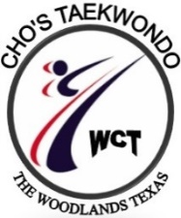
Cho’s TaeKwonDo / Ivy Kids
2018 Fall Membership Application

Student Name:______________________________Date of Birth:________________________
Gender:______________Grades ______________Teacher ______________________________
List any major medical problems:___________________________________________________
Parents (Guardians)
Name:________________________________ Occupation: (optional)_____________________
Adress:_______________________________________________________________________
City:___________________________________________ Zip:___________________________
Phone:___________________________E-mail:_______________________________________
Your expectation or goals through TaeKwonDo training: _______________________________

I hereby make application for membership at Cho’s TaeKwonDo Institute and upon acceptance I sincerely pledge to obey all the rules and regulations which are established for keeping the order of this school and for the protection of the students from injury. I pledge never to use the techniques learned at this school except to protect the honor of the well-being of myself or the defenseless. I will never do anything to bring disgrace up this school. In consideration of accepting my entry into this school, I hereby release Cho’s TaeKwonDo School, the owner, instructors, members and Ivy Kids from all repair abilities and all claims for injuries I may receive from practicing TaeKwonDo. I further concern that any pictures furnished by or taken of me, in connections with Activities, may be used for promotion or television showing, and I may waive compensation in regard there to. I understand that tuition fees must be paid in advance. There will be NO refunds under any circumstances.
IF UNDER 18, THIS APPLICATION MUST BE SIGNED BY PARENTS OR LEGAL GUARDIAN
Fee: $59 per Month, T-shirt FREE ($15 Cost)
Register online www.chotkd.com – to get started. Click Ivy Kids. Or mail to Address
Applicant’s Signature:____________________________________ Date:________________
Instructor’sSignature:_____________________________________Date:________________

